Azure Assignment

(AZ – 104- Module 6)

Avishekh Sinha

# Module 6 – AZURE NETWORKING -I

## Assignment 1

1. Create a Virtual network in West US
2. Create another Virtual Network in South India
3. Deploy virtual machine in West US with the Virtual network in west us
4. Deploy Virtual machine in South India inside virtual network in South India
5. Create Vnet-Vnet Peering to connect West US and South India VM
6. Check this by pinging VM1 to VM2 via ping command using private ip address

|  |  |
| --- | --- |
| CREATE A VIRTUAL NETWORK IN WEST US |  |
| CREATE ANOTHER VIRTUAL NETWORK IN SOUTH INDIA  Note – The Azure Pass Subscription does not allow us to create VMs in South India. Hence creating in Central US |  |
| DEPLOY VIRTUAL MACHINE IN WEST US WITH THE VIRTUAL NETWORK IN WEST US | |
| VM1 – IN WEST US | VM2 – IN SOUTH INDIA |
| Create Vnet-Vnet Peering to connect West US and South India VM | |
|  | |
|  | |
| Check this by pinging VM1 to VM2 via ping command using private ip address   1. Connect to VM1 using Bastion (As VM1 don’t have private IP address) | |
| 1. Run the following command in Both the VM   **New-NetFirewallRule –DisplayName “Allow ICMPv4-In” –Protocol ICMPv4** | |
| PING VM1 to VM2 | |

## Assignment 2

1. Create a VM in West US

2. Assign a Static IP address to the VM

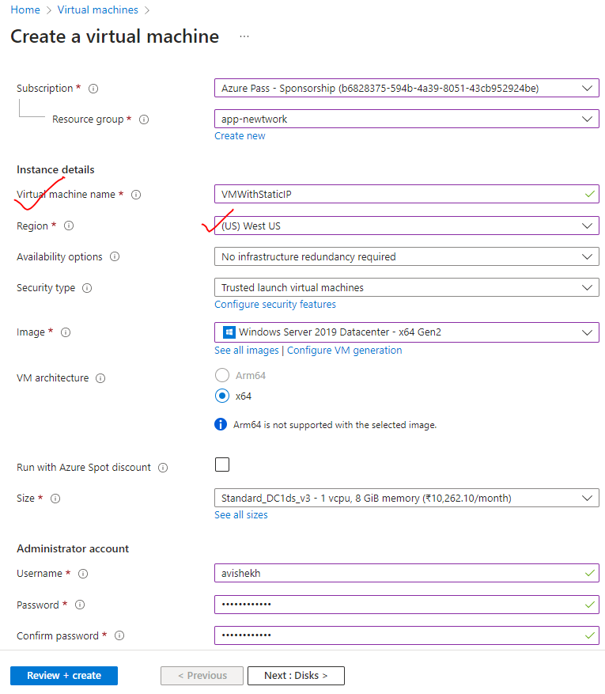

2. Assign Static IP to the VM 🡪 Save

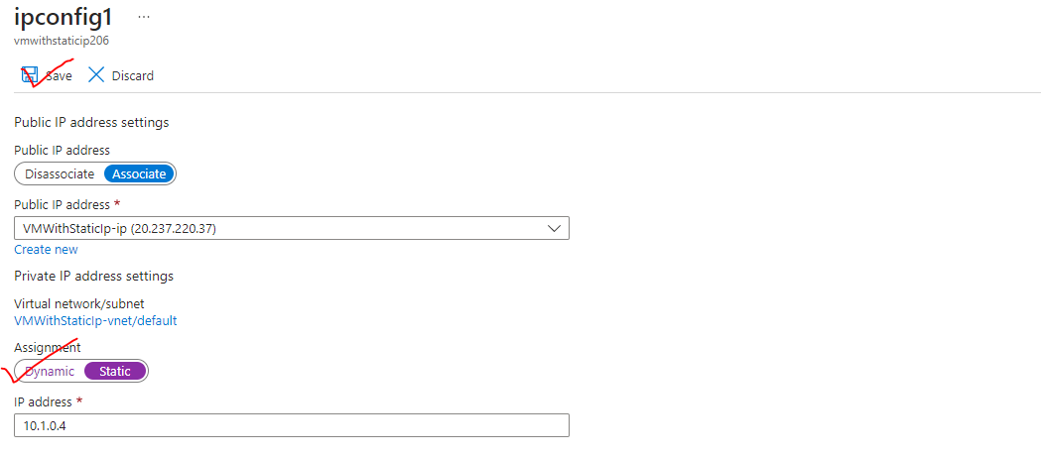

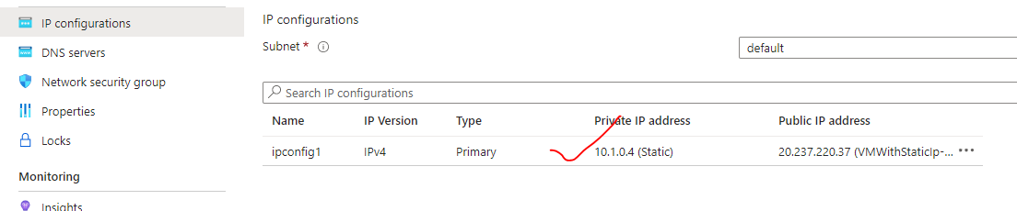

## Assignment 3

Use the previously created VM

2. Created a NIC

3. Attach NIC to the previously created VM

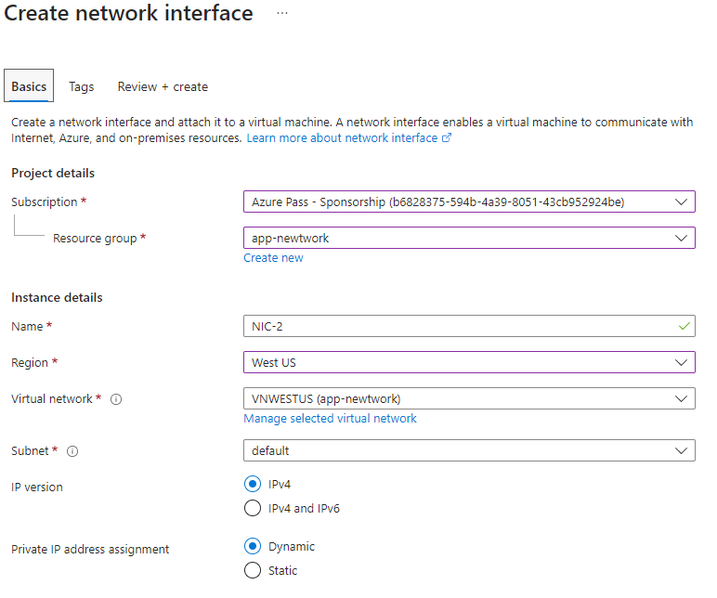

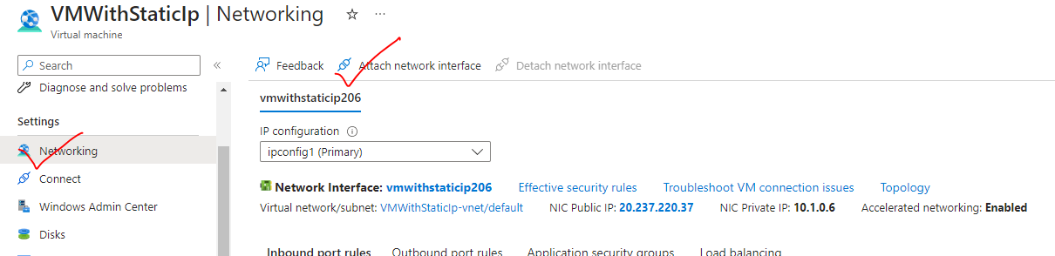

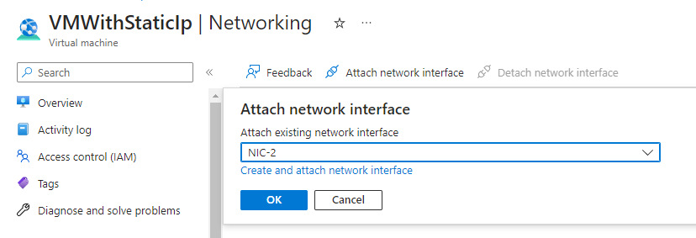

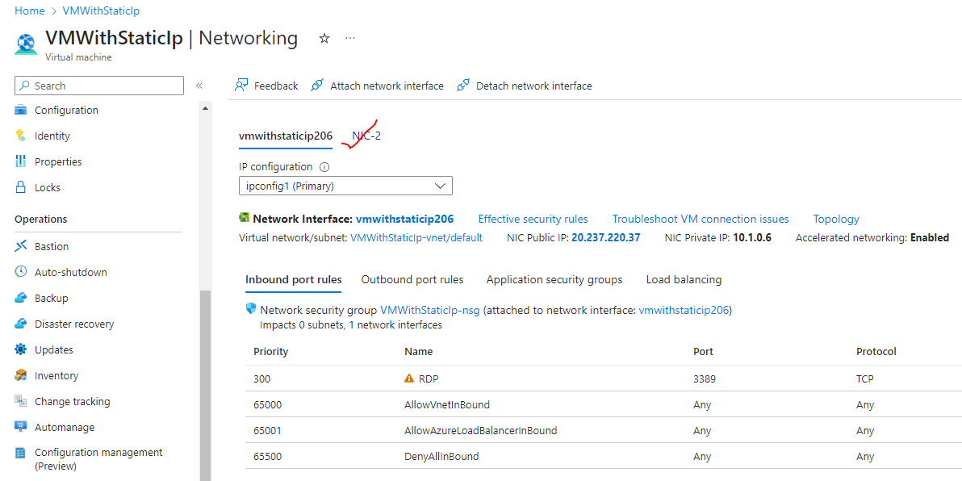

## Assignment 4

1. Use the previously created Linux VM
2. Install apache2 on this VM
3. Created a Network Security Group to the subnet in which VM has been deployed
4. Open NSG rules for subnet and VM on port 80
5. Verify if you can see the apache2 page

|  |  |
| --- | --- |
| INSTALL APACHE 2 |  |
| CREATE NSG |  |
| ASSOCIATE THE NSG WITH A SUBNET | |
| ADD INPUT RULE TO PORT -80 AT SUBNET LEVEL | |

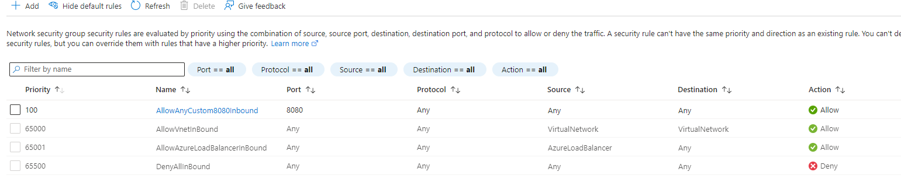

ADD NSG RULE FOR POR 80 AT NETWORK INTERFACE

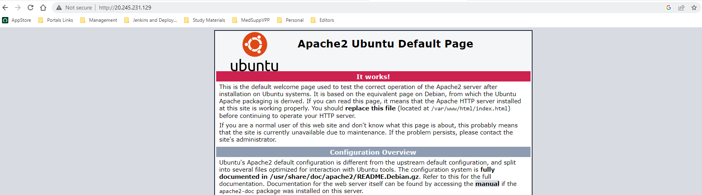

## Assignment 5

Use the previously created apache2 VM

2. Get a free domain from freenom.com

3. Use Azure DNS to point this free domain to your VMs IP